**CSC 370 – Database Systems**

Dr. Sean Chester

**Movie Rating System**

Project Sprint: 1 Revision

June 8th, 2024

Team27J

Alyssa Taylor V00987477

Karan Gosal V00979752

1. Addressing Feedback for **[Planning]Improvement wrt course-level competencies:**

For the Course Level Competency, we are currently at ***Level-1*** for both *Data Modelling* and *Data Analytics* as we have accomplished these.

Considering the information from the competencies from lecture, in detail:   
  
We have achieved Level 1 for Data Analytics, demonstrating the ability to write code that effectively manipulates relational databases to achieve specific outcomes, anticipate query results, and express query intents using declarative SQL and relational operators. This includes accurately extracting data with selection predicates and attribute projections, combining data from multiple tables using appropriate JOIN operations, and modifying data in bulk with set-theoretic SQL DML queries. Additionally, we have mastered Level 1 data modelling, which include storing data in tables with suitable data types, implementing relational designs, loading data from .CSV formats without loss, appending new data to existing tables, adjusting their structures as needed, and documenting table relationships using accurate entity-relationship diagrams. These competencies form a strong foundation for managing and manipulating data effectively within relational database systems.

By the **end of next Sprint** i.e., Sprint 2, We will accomplish the ***Level-2*** for both *Data Modelling* and *Data Analytics*.

1. Addressing Feedback for **[Planning] Coverage of next sprint plan with newly covered module competencies:**

*For individual command, please see the file in the folder ‘csv_commands.sql’*

**Uploading CSV files:**

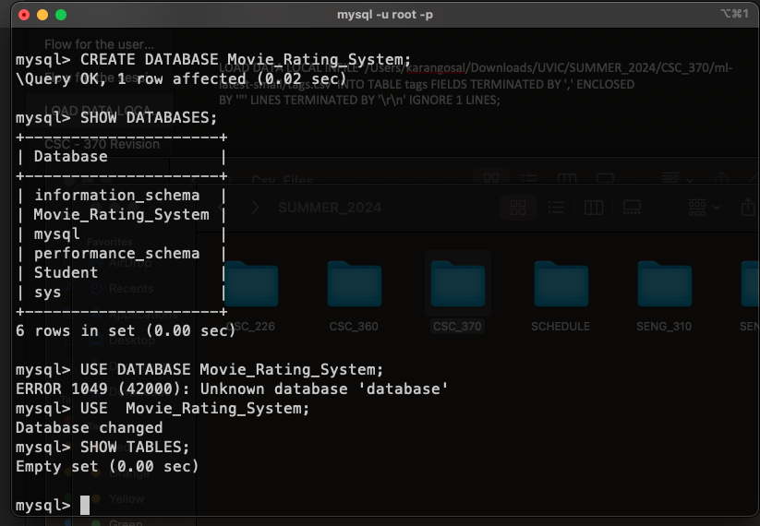

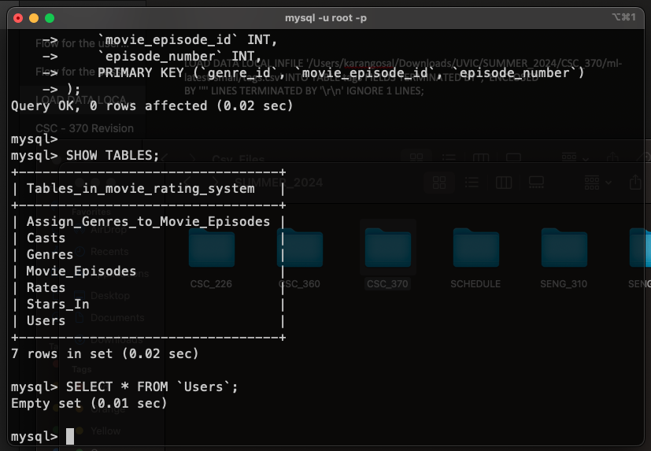

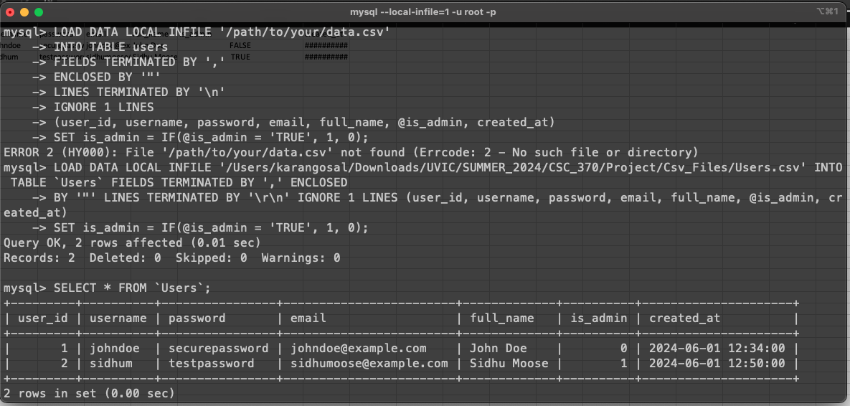

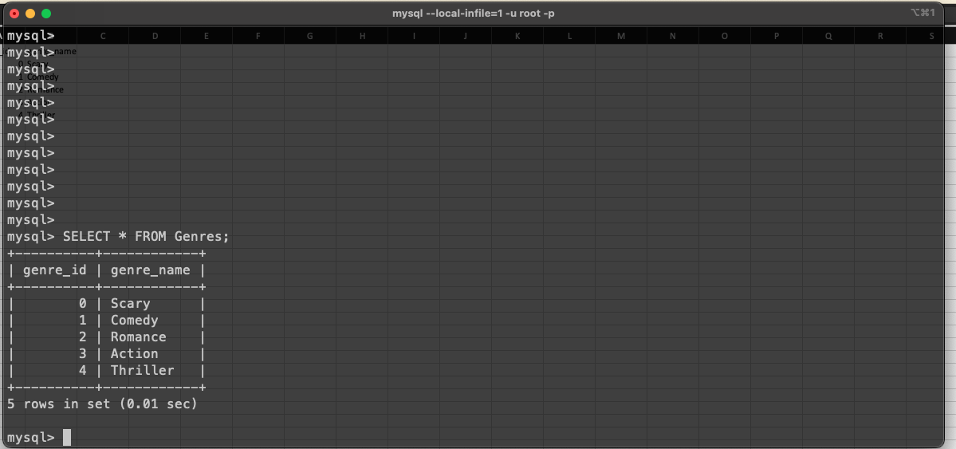

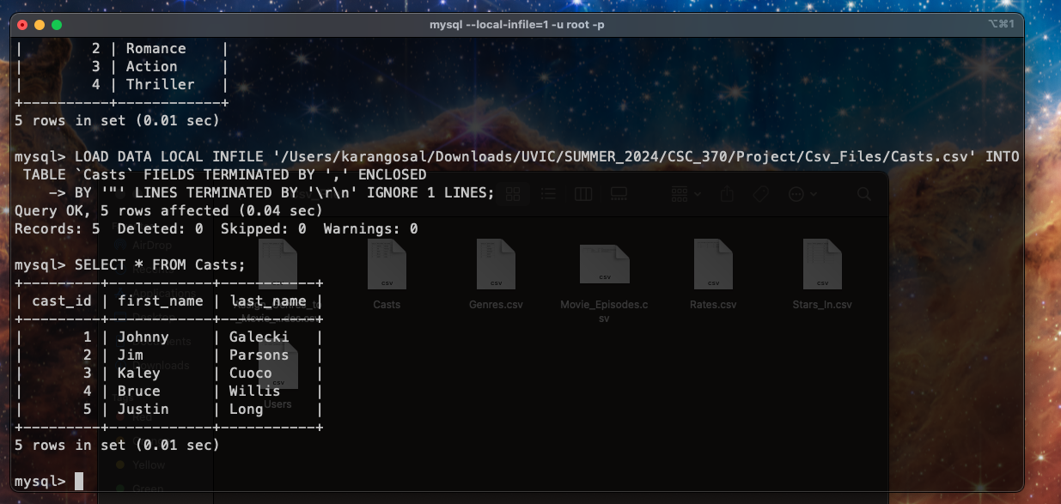

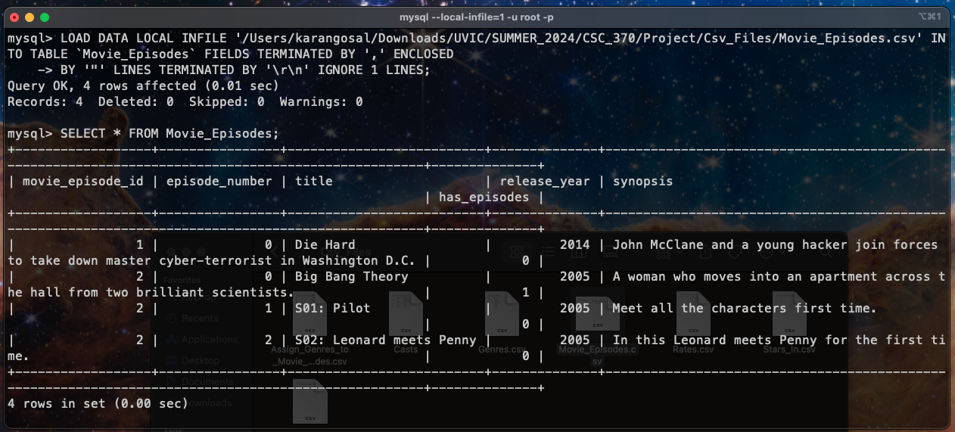

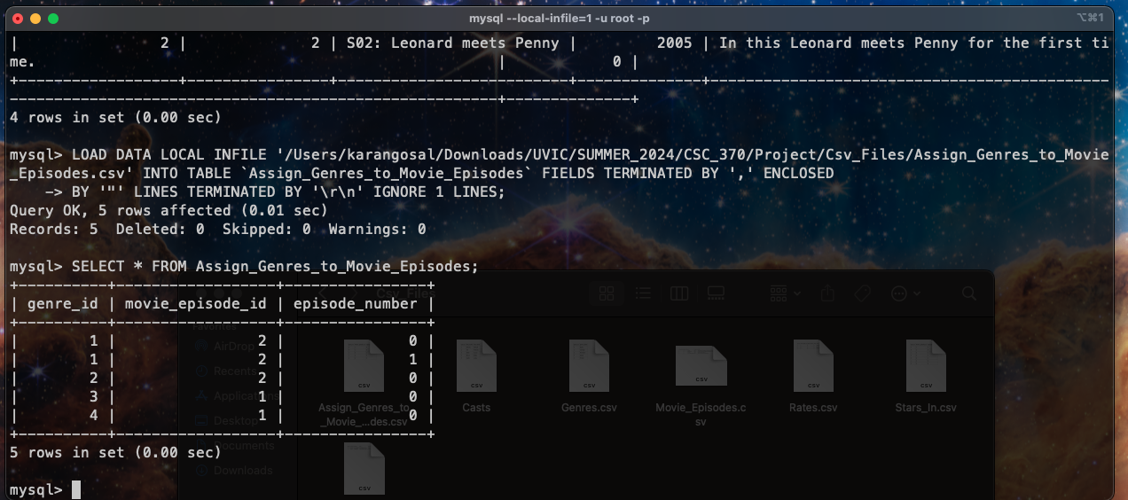

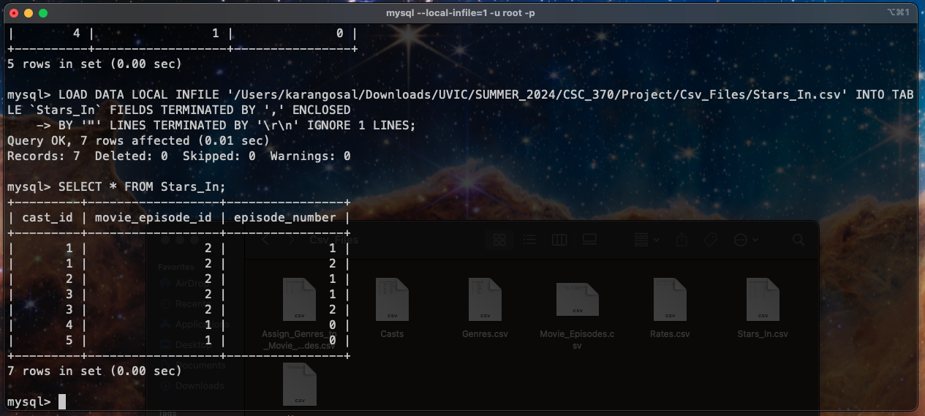

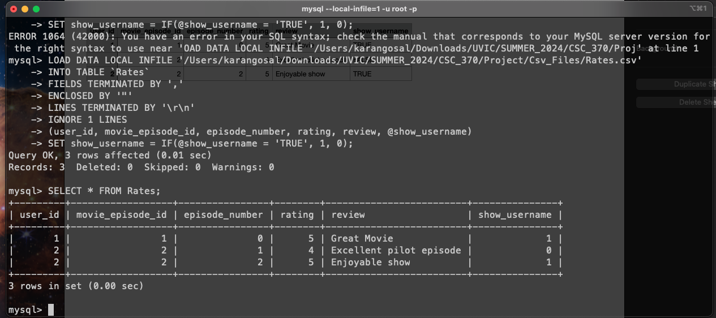

Example for the JOIN:  
  
